Who are the people that make up this group?
We are a group of breeders and fanciers passionate about eliminating HCM (Hypertrophic Cardiomyopathy) in the Norwegian Forest Cat (NFO). We share our knowledge and experiences, screen our cats regularly and share the results publicly, organize HCM screening clinics, and donate our money to the NFC DNA research fund.
A gene that causes HCM in the Maine Coon cat has been identified by Dr. Kittleson, Dr Meurs, and a team of researchers spanning several universities. The NFC HCM Research Group actively works with the Norwegian Forest Cat community to promote HCM awareness and to promote current research efforts to identify genes that cause HCM in the Norwegian Forest Cat. To help fund this research, we rely on fundraisers and private donations through the Winn Feline Foundation.
We created a web site to educate breeders and fanciers about HCM and provide updates on the Norwegian Forest Cat HCM Research Project. HCM educational material is available in various languages. We encourage you to share this information with fellow breeders and fanciers around the world.

Join the NFC HCM Discussion Group on Facebook

https://www.facebook.com/groups/
nfchcm.updates/

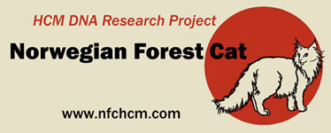

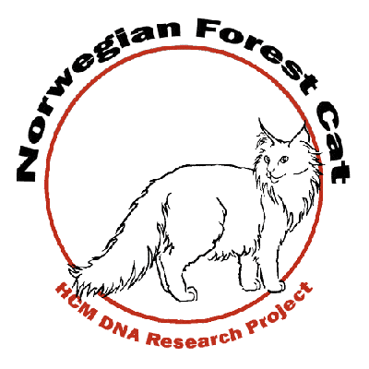

Breeders & Fanciers

working together for the love of the breed.

Our Mission Statement
To foster awareness and encourage screening for hypertrophic cardiomyopathy (HCM) in the Norwegian Forest Cat (NFO) and support research directed towards finding a DNA test for HCM in the Norwegian Forest Cat.
Our Goals
- Increase awareness of HCM with access to current research and documentation
- Promote HCM screening with the best means available (currently Echocardiogram)
- Organize and conduct testing clinics nationally and internationally, making tests widely available at a reasonable cost
- Provide a centralized data bank for online test documentation
- Support development of DNA screening through fund raising, recruiting sponsors and fostering awareness

FAQ’s
Where does my donation go?
All monies raised by raffles and fundraisers are sent to the WINN Foundation to an account that has been created specifically for NFO HCM research.
What is the WINN Foundation?
The Winn Feline Foundation is a non-profit organization, affiliated with The Cat Fanciers' Association, Inc., which supports health related studies into medical problems affecting cats. Their web address is http://www.winnfelinehealth.org
Can I make a donation directly to WINN?
Yes!! Go to:
https://donate.towercare.com/winnfeline
When asked “How would you like your funds used?:”
Select: I would like to choose a specific purpose for this donation
At the next question “Specific Purpose:”
Select: Norwegian Forest Cat-HCM

FAQ’s continued
How can I learn more about the Norwegian Forest Cat and HCM
Please visit our website at http://www.nfchcm.com This site contains updated information on current raffles & auctions, donation tallies, and many HCM articles and web links.

How can I help?
You can help by participating in raffles, donating money, and educating yourself and others about the importance of screening for HCM.

